CN EXP 7:

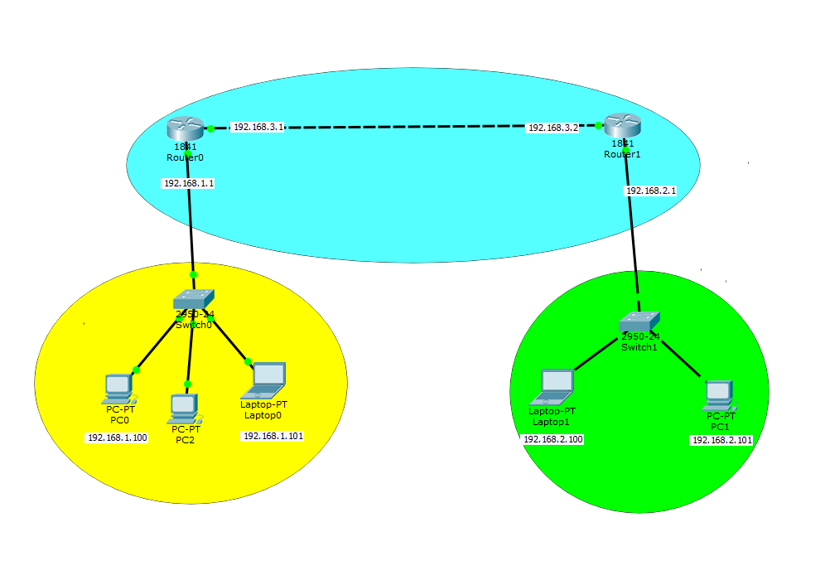

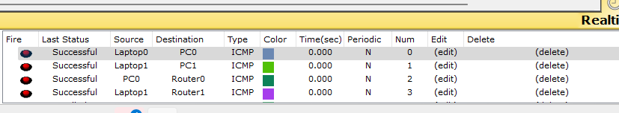



CODE ROUTER 0:

Continue with configuration dialog? [yes/no]: n

Press RETURN to get started!

Router>enable

Router#configure terminal

Enter configuration commands, one per line. End with CNTL/Z.

Router(config)#interface FastEthernet0/0

Router(config-if)#

Router(config-if)#exit

Router(config)#interface FastEthernet0/0

Router(config-if)#ip address 192.168.1.1 255.255.255.0

Router(config-if)#no shutdown

Router(config-if)#

%LINK-5-CHANGED: Interface FastEthernet0/0, changed state to up

%LINEPROTO-5-UPDOWN: Line protocol on Interface FastEthernet0/0, changed state to up

Router(config-if)#exit

Router(config)#router rip

Router(config-router)#network 192.168.1.0

Router(config-router)#network 192.168.3.0

Router(config-router)#

Router(config-router)#exit

Router(config)#interface FastEthernet0/0

Router(config-if)#

Router(config-if)#exit

Router(config)#interface FastEthernet0/1

Router(config-if)#

Router(config-if)#exit

Router(config)#interface FastEthernet0/0

Router(config-if)#

Router(config-if)#exit

Router(config)#interface FastEthernet0/1

Router(config-if)#ip address 192.168.3.1 255.255.255.0

Router(config-if)#no shutdown

Router(config-if)#

%LINK-5-CHANGED: Interface FastEthernet0/1, changed state to up

Router(config-if)#exit

Router(config)#router rip

Router(config-router)#

%LINEPROTO-5-UPDOWN: Line protocol on Interface FastEthernet0/1, changed state to up

Router con0 is now available

Press RETURN to get started.

ROUTER 1:

Continue with configuration dialog? [yes/no]: n

Press RETURN to get started!

Router>enable

Router#configure terminal

Enter configuration commands, one per line. End with CNTL/Z.

Router(config)#interface FastEthernet0/0

Router(config-if)#

Router(config-if)#exit

Router(config)#interface FastEthernet0/0

Router(config-if)#ip address 192.168.1.1 255.255.255.0

Router(config-if)#no shutdown

Router(config-if)#

%LINK-5-CHANGED: Interface FastEthernet0/0, changed state to up

%LINEPROTO-5-UPDOWN: Line protocol on Interface FastEthernet0/0, changed state to up

Router(config-if)#exit

Router(config)#router rip

Router(config-router)#network 192.168.1.0

Router(config-router)#network 192.168.3.0

Router(config-router)#

Router(config-router)#exit

Router(config)#interface FastEthernet0/0

Router(config-if)#

Router(config-if)#exit

Router(config)#interface FastEthernet0/1

Router(config-if)#

Router(config-if)#exit

Router(config)#interface FastEthernet0/0

Router(config-if)#

Router(config-if)#exit

Router(config)#interface FastEthernet0/1

Router(config-if)#ip address 192.168.3.1 255.255.255.0

Router(config-if)#no shutdown

Router(config-if)#

%LINK-5-CHANGED: Interface FastEthernet0/1, changed state to up

Router(config-if)#exit

Router(config)#router rip

Router(config-router)#

%LINEPROTO-5-UPDOWN: Line protocol on Interface FastEthernet0/1, changed state to up

Router con0 is now available

Press RETURN to get started.

